BIT3208: ADVANCED WEB DESIGN AND DEVELOPMENT
PRACTICAL LOGBOOK AND REPORT

WEEK 1 TO WEEK 5 – CAPSTONE PROJECT

Student Name: JOSEPH KINUTHIA
Admission Number: BBIT202456504
Course/Class: Bachelor of Business Information Technology
Unit Code: BIT3208
Unit Name: Advanced Web Design and Development
Lecturer’s Name: Mr. Nyoro Michael
Semester/Academic Year: YEAR 3 SEM 2, 2026

PROJECT DETAILS

Project Title: Smart E-Commerce

Selected Technologies:
- Frontend: HTML5, CSS3, JavaScript
- Backend: PHP 8.2
- Database: MySQL (MariaDB)
- Server: XAMPP (Apache)
- Version Control: Git & GitHub

ONLINE PORTFOLIO / GITHUB

GitHub Repository: https://github.com/joeflinch31/smart-ecommerce-capstone

Local Development: http://127.0.0.1/week1/

TABLE OF CONTENTS

Section | Title | Pages
1 | Executive Summary | 1
2 | Week 1: Environment Setup | 2
3 | Week 2: UI/UX & Frontend | 3
4 | Week 3: JavaScript & PHP | 4
5 | Week 4: Server-Side | 5
6 | Week 5: Database & CRUD | 6
7 | Project Summary | 7
8 | Figma Design & Prototype | 8
9 | Database Exports | 9
10 | GitHub Repository | 10
11 | Conclusion | 11
12 | Appendices | 12

1. EXECUTIVE SUMMARY
This report documents the development of a Smart E-Commerce Web Application completed over five weeks as part of the BIT3208 course. The project involved building a fully functional e-commerce platform from scratch using PHP, MySQL, HTML, CSS, and JavaScript.
Key Achievements:
- Successfully set up local development environment using XAMPP
- Designed wireframes and GUI layouts using Figma
- Implemented frontend with HTML/CSS and JavaScript validation
- Developed backend with PHP including user authentication and session management
- Created database-driven application with full CRUD operations
- Built shopping cart and order processing system

WEEK 1: LOCAL ENVIRONMENT SETUP

Title: Installation and Testing of Local Development Environment

Fig 1.1: XAMPP Installation Directory

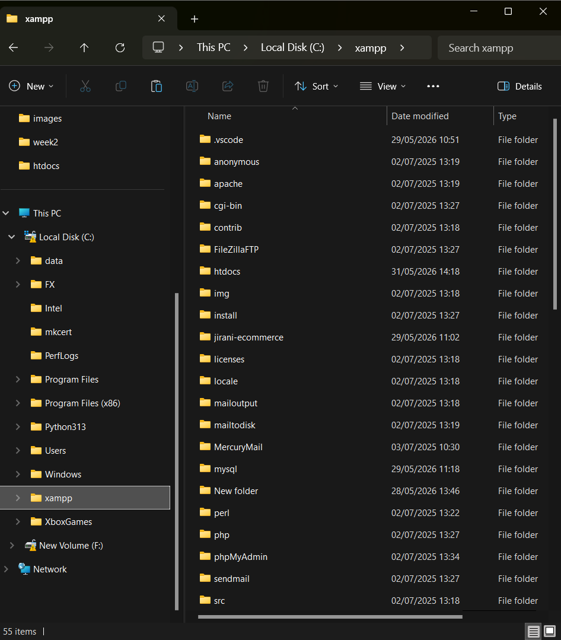

Figure 1.1 shows the XAMPP installation directory at
C:\xampp containing all required subfolders including Apache,
MySQL, PHP, phpMyAdmin, and htdocs.

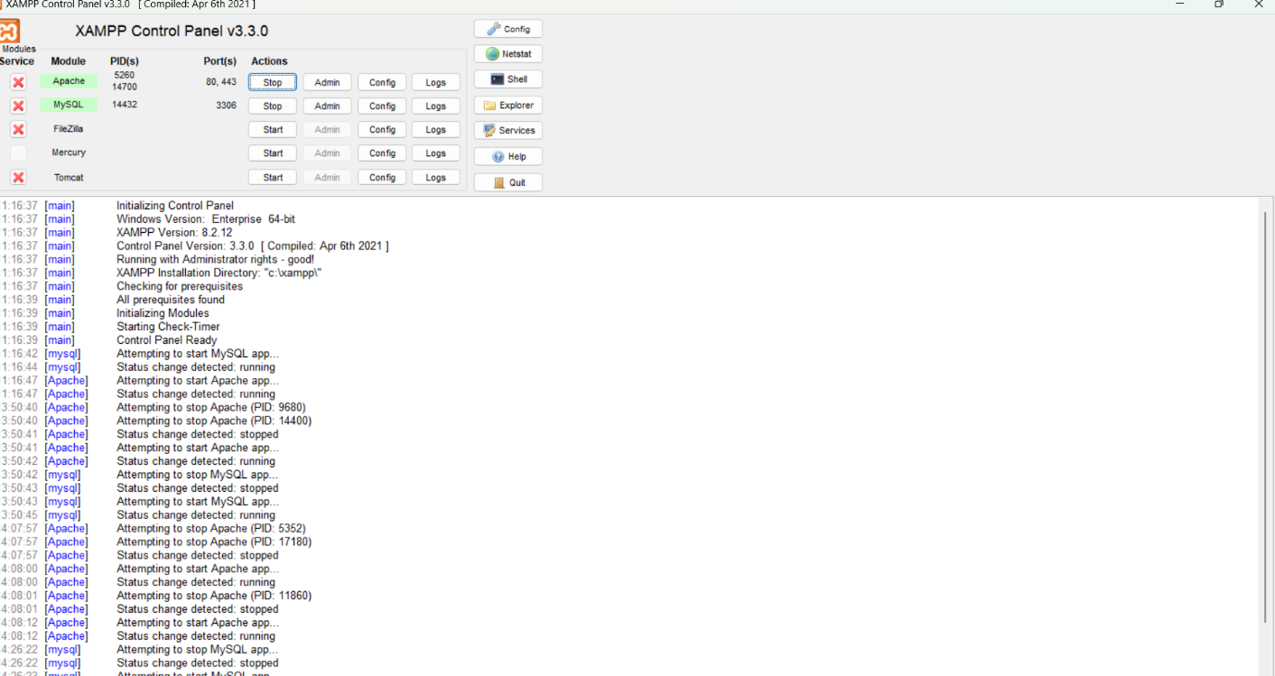

Figure 1.2 shows the XAMPP Control Panel with Apache
and MySQL running (green status).

Fig 1.3: Localhost Server Test

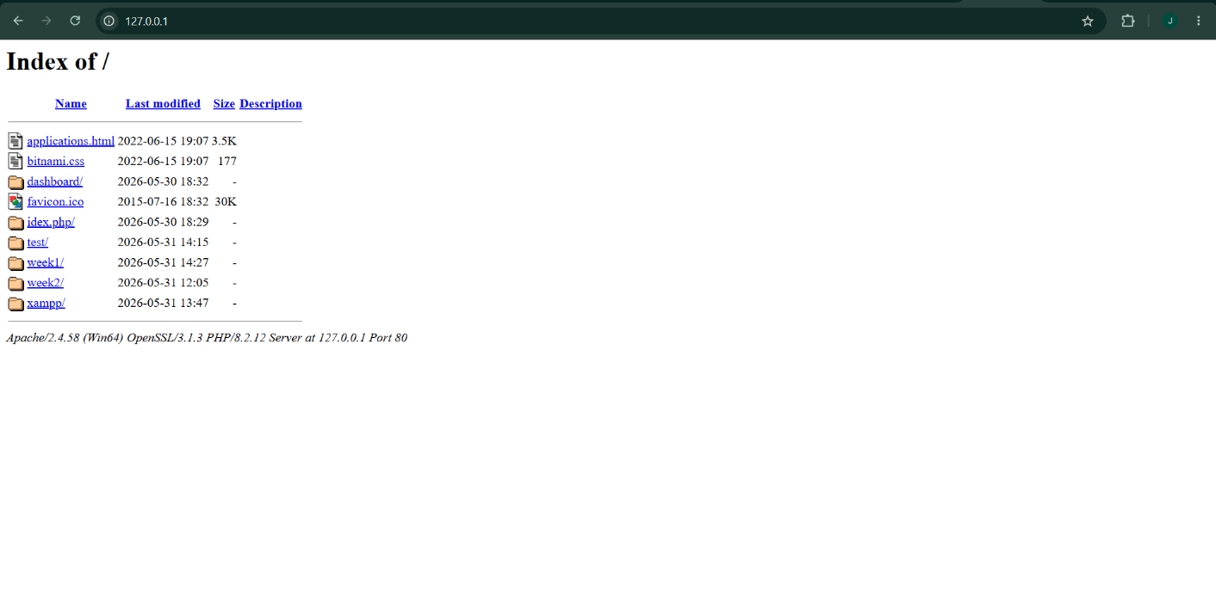

Figure 1.3 shows the browser displaying http://127.0.0.1/
with the week1 folder visible.

Fig 1.4: Week1 Project Folder Structure

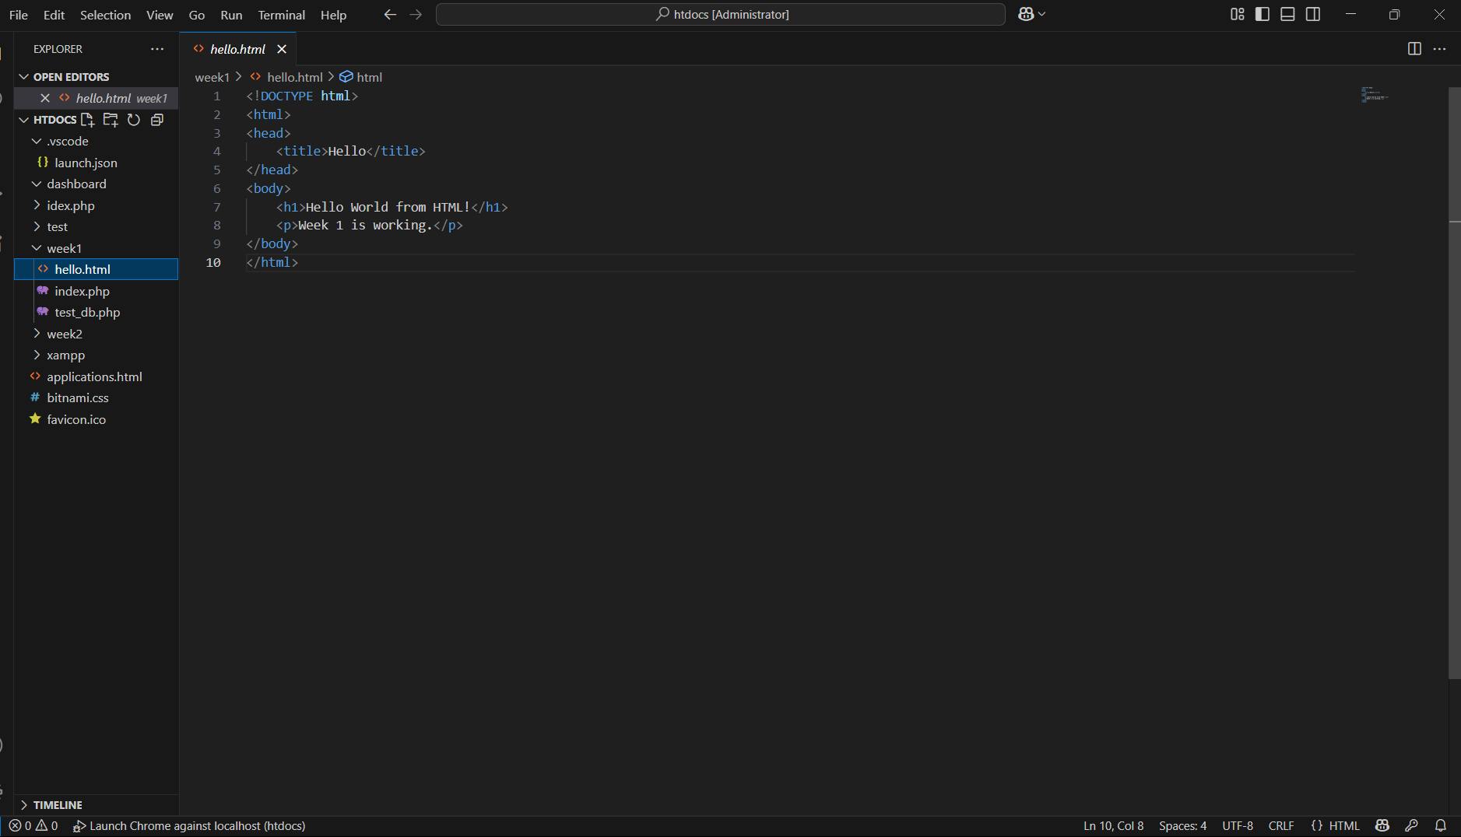

Figure 1.4 shows the Week1 folder containing hello.html,
index.php, and test_db.php.

Fig 1.5: HTML Hello World Page

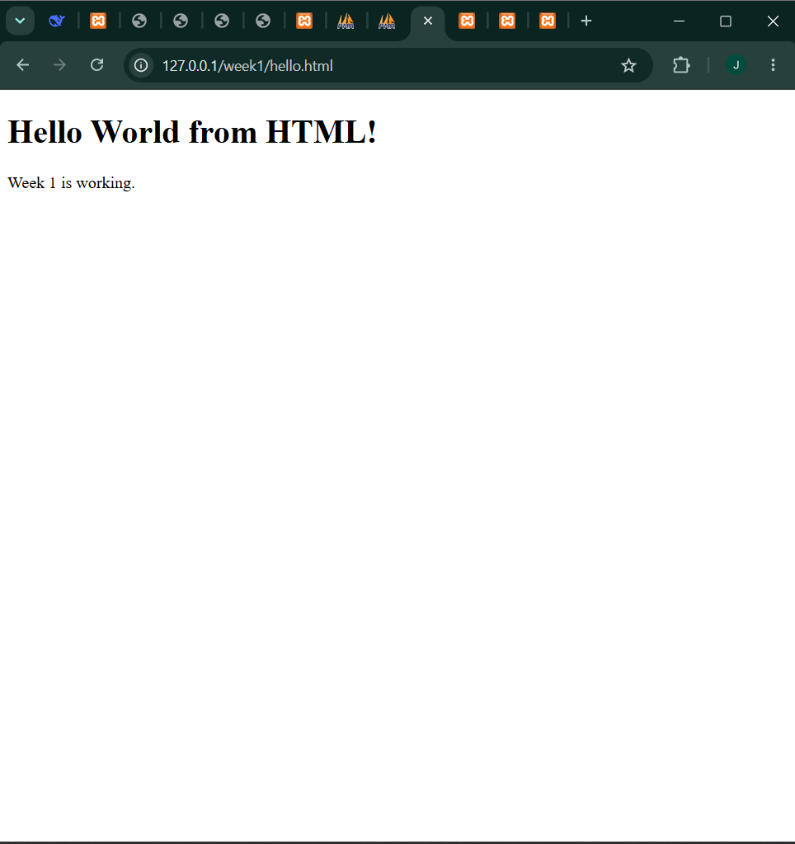

Figure 1.5 shows the HTML Hello World page at
http://127.0.0.1/week1/hello.html displaying "Hello World!".

Fig 1.6: PHP Hello World Page

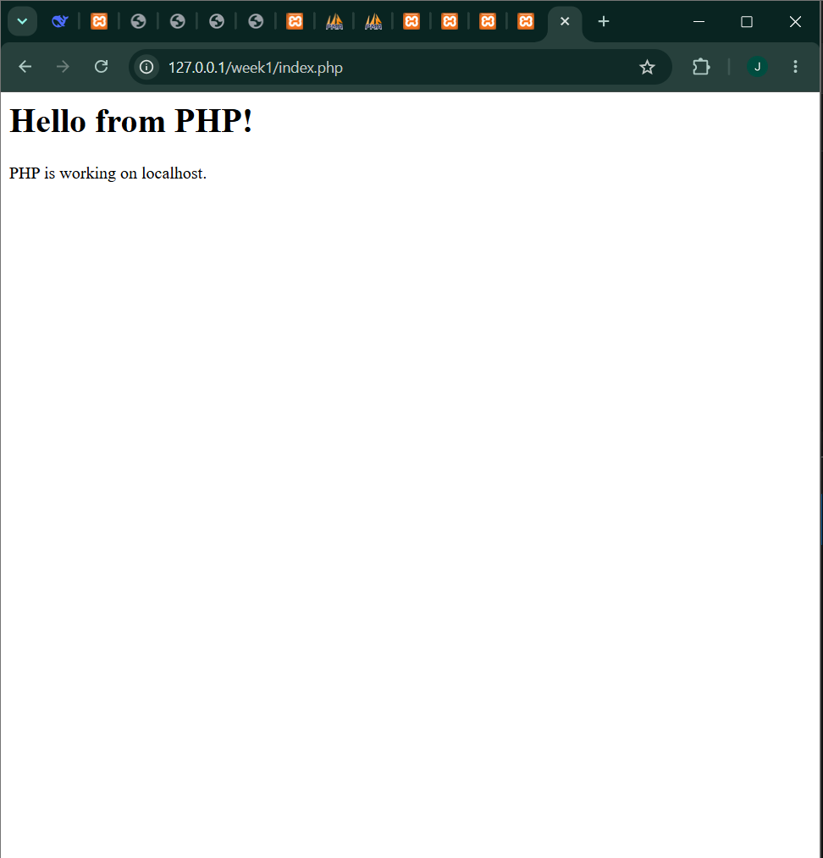

Figure 1.6 shows the PHP Hello World page at
http://127.0.0.1/week1/index.php displaying "Hello from PHP!".

Fig 1.7: Database Connection Test

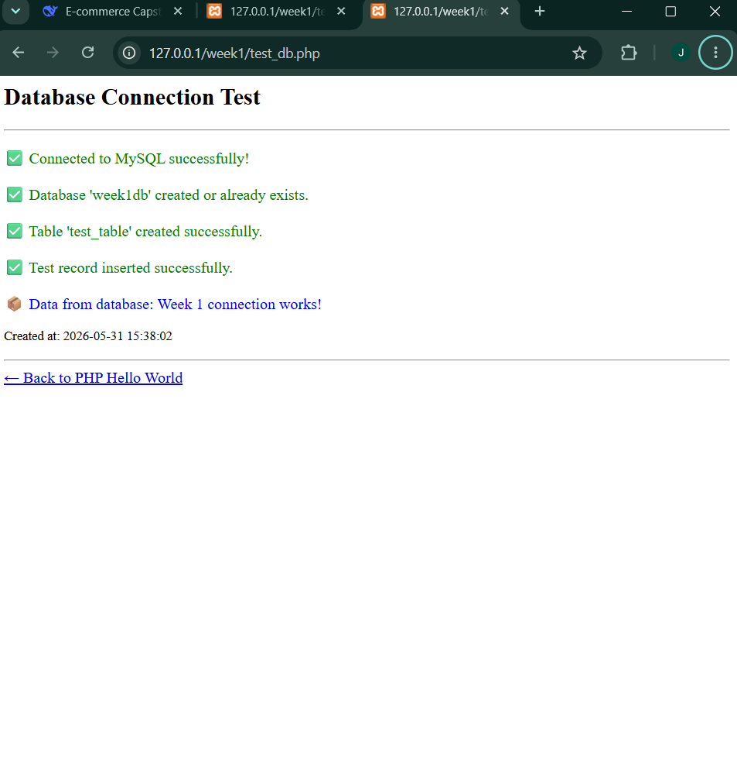

Figure 1.7 shows the database test with green checkmarks
confirming MySQL connection, database creation, table creation,
and data insertion.

Fig 1.8: phpMyAdmin Database Verification

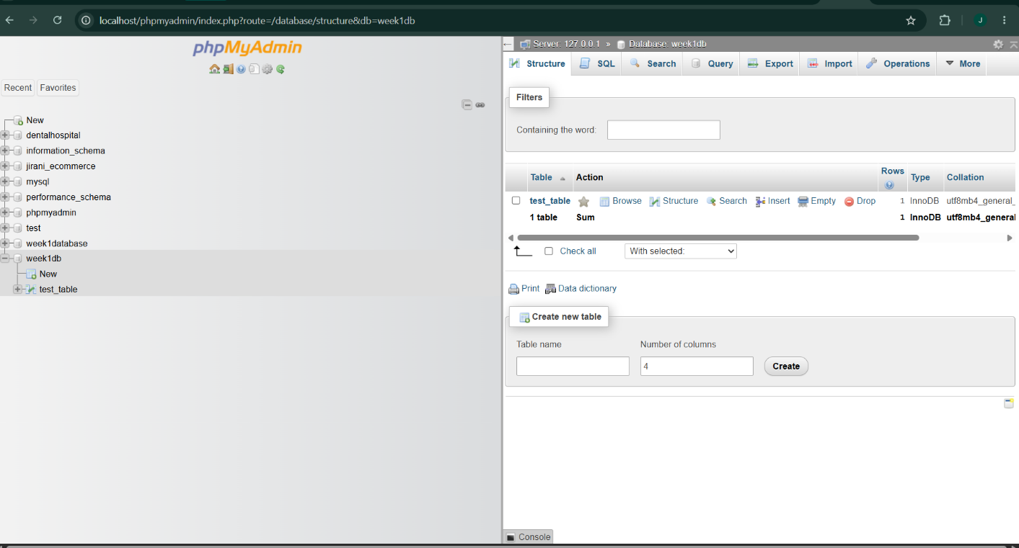

Figure 1.8 shows phpMyAdmin with week1db database and
test_table containing the test record.

WEEK 1 REFLECTION

During Week 1, I successfully set up my local development
environment using XAMPP 8.2.12 with Apache and MySQL services.
I created three test files: hello.html (pure HTML), index.php
(PHP processing), and test_db.php (database connection script).
The PHP script connects to MySQL, creates database week1db,
creates test_table, inserts a test record, and reads it back -
all confirmed through phpMyAdmin. The main challenge was
understanding the document root location (C:\xampp\htdocs) where
all project files must be placed. I learned the difference
between static HTML (client-side) and PHP (server-side) execution.

WEEK 1 COMPLETION CHECKLIST

XAMPP installed
Apache server running
MySQL server running
Localhost accessible
hello.html created
index.php created
test_db.php created
Database week1db created
Table test_table created
Test record inserted
Database exported
All screenshots taken

WEEK 2: WIREFRAMES AND GUI DESIGN

Title: User Interface Planning and System Design

Fig 1: Hand-drawn Wireframe (Homepage)

C Fig 1 shows the initial wireframe design for the e-commerce homepage in Figma, featuring a dark header with logo and navigation menu (Home, Cart, Login, Register), a page title "Our Products", and a product grid layout with 6 product cards.

Fig 2: Dashboard Layout Design (Homepage Complete)
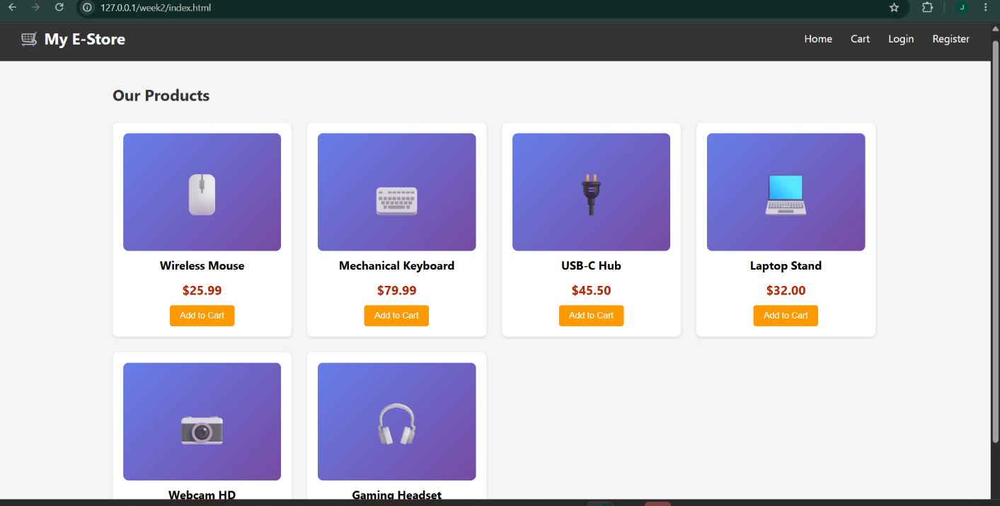
Fig 2 displays the complete homepage/dashboard layout with 6 product cards. Each card contains an image placeholder, product name (Wireless Mouse, Mechanical Keyboard, USB-C Hub, Laptop Stand, Webcam HD, Gaming Headset), price, and an "Add to Cart" button.

Fig 3: Mobile View Mockup
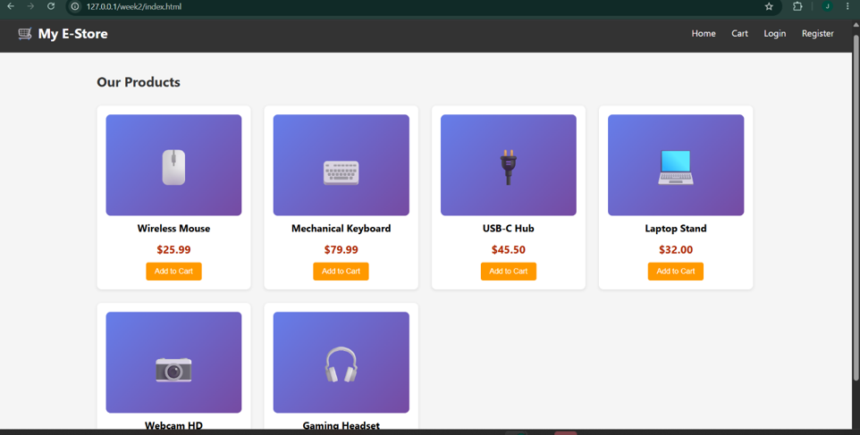
Fig 3 demonstrates the responsive design of the homepage on mobile view. The product grid adjusts from 3 columns on desktop to 1 column on mobile, and the navigation menu becomes vertically stacked for better usability on small screens.

Fig 4: Color Theme and Navigation Structure


Fig 4 illustrates the color theme and navigation structure used consistently across all pages. The header uses dark gray (#333333) with white text for the logo and navigation links. The "Add to Cart" buttons use orange (#FF9900) to attract user attention. The navigation includes Home, Cart, Login, and Register links.

Fig 5: GUI Prototype in Figma (All 4 Frames)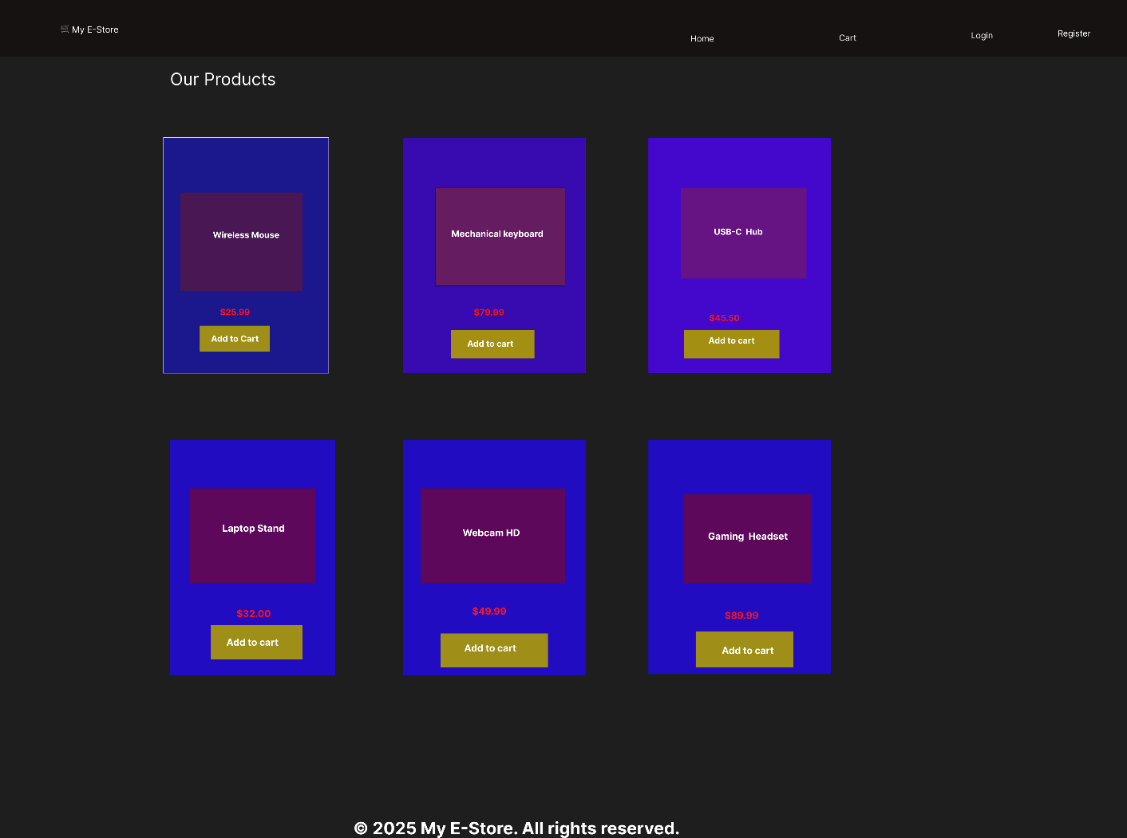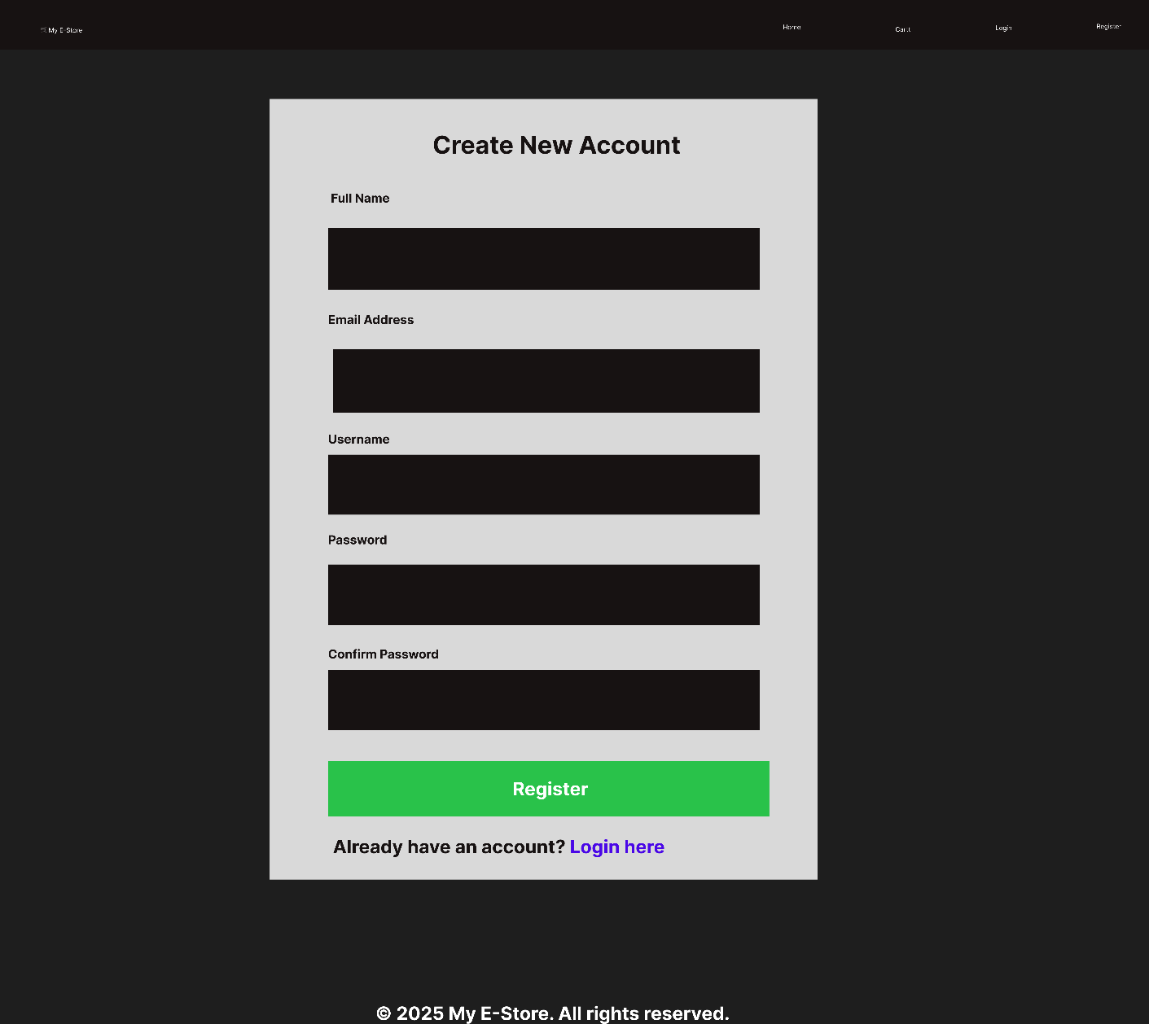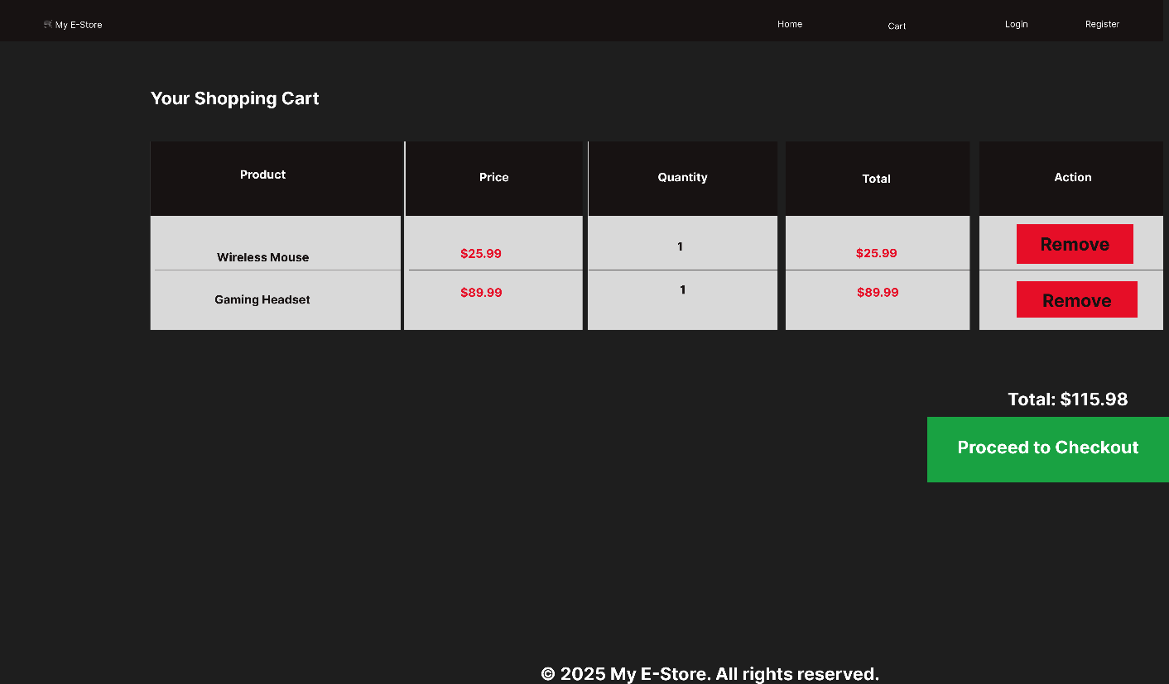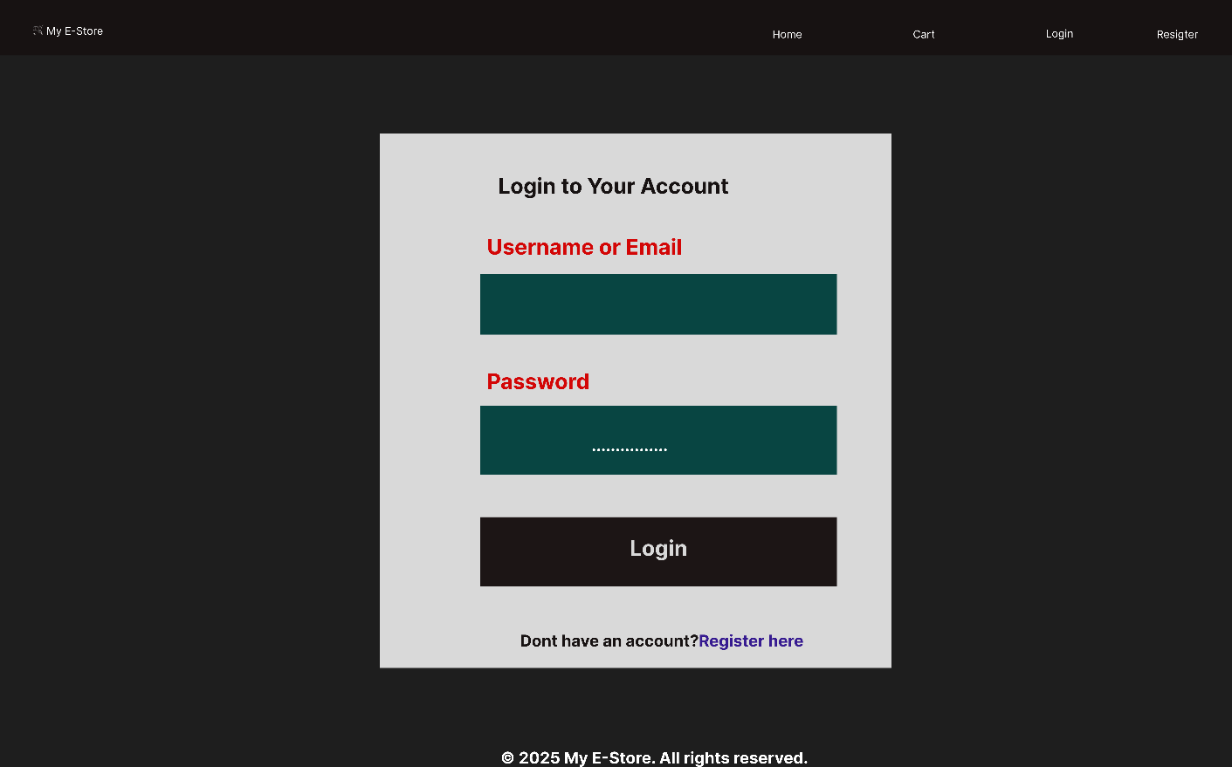

Fig 5 shows the complete Figma prototype with four frames: Homepage, Login, Register, and Cart. This demonstrates the full user flow of the e-commerce application, from browsing products to logging in, registering, and viewing the shopping cart.

Fig 6: HTML/CSS Homepage Implementation
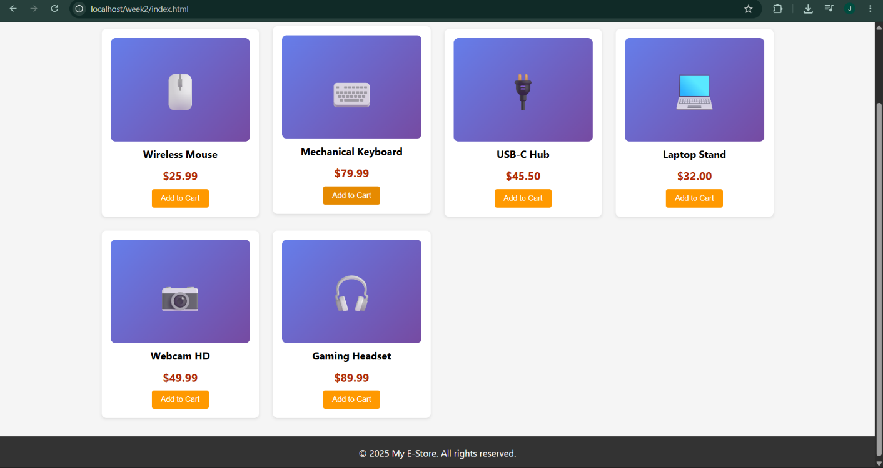
Fig 6 shows the working homepage implemented in HTML/CSS, matching the Figma wireframe design. All 6 product cards are displayed with product names, prices, and Add to Cart buttons. The page is fully responsive and tested in Chrome browser.

Fig 7: Login Page Implementation

Fig 7 displays the login page with username/email field, password field, login button, and a "Register here" link for new users. The form is styled consistently with the overall color theme.

Fig 8: Register Page with Password Validation
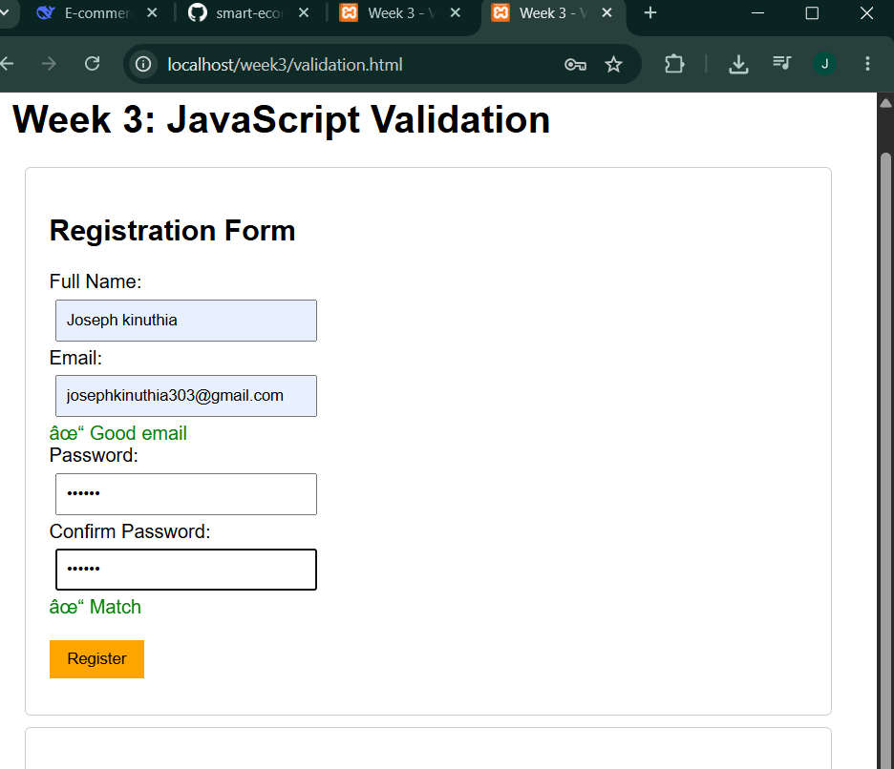 Fig 8 demonstrates the registration page with real-time password validation using JavaScript. When passwords match, a green checkmark and "✓ Passwords match" message appear. This improves user experience by providing immediate feedback before form submission.

Fig 9: Shopping Cart Page
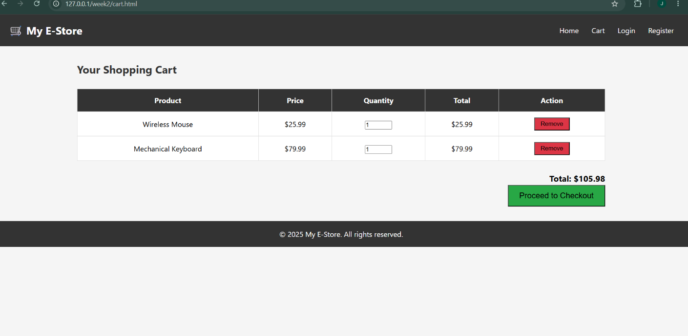
Fig 9 shows the shopping cart page with product table containing columns: Product, Price, Quantity, Total, and Action. Sample products (Wireless Mouse and Gaming Headset) are displayed with quantity selectors, remove buttons, total amount ($105.98), and a green "Proceed to Checkout" button.

Fig 10: Project Folder Structure
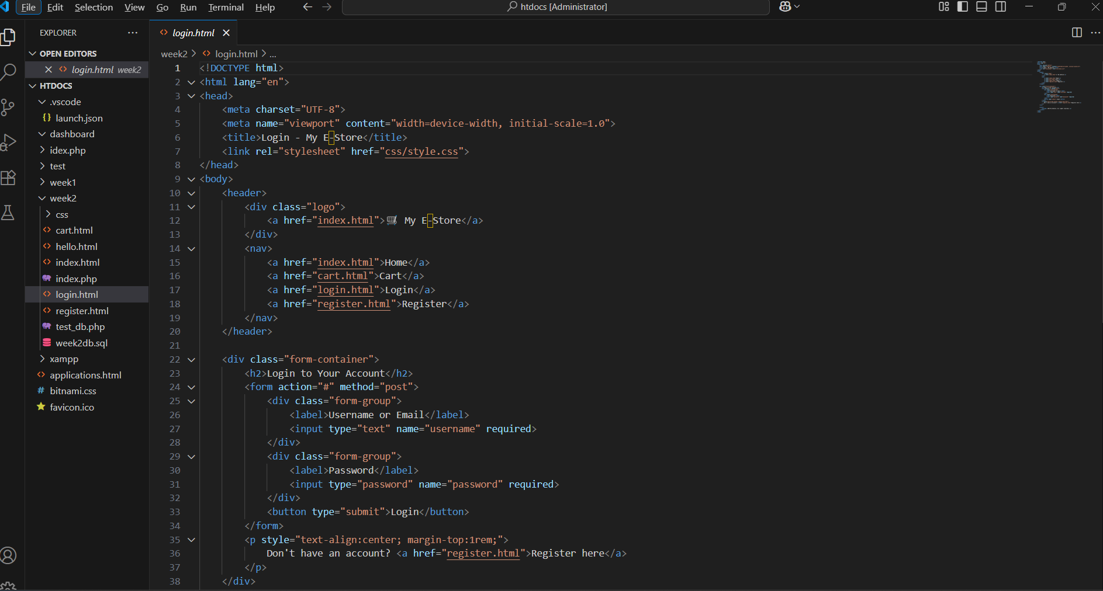

Fig 10 presents the project folder structure (week2/css/, week2/images/, index.html, login.html, register.html, cart.html). This demonstrates organized code management following professional software development practices.

Student Reflection (Maximum 100 Words)
During Week 2, I designed wireframes for four pages: Homepage, Login, Register, and Cart using Figma. The layout includes a dark header with navigation links (Home, Cart, Login, Register) for easy access. The homepage features a responsive product grid with 6 product cards, each containing an image placeholder, product name, price, and Add to Cart button. I considered user experience by keeping navigation consistent and forms simple. The design is mobile-responsive using CSS Grid, adjusting from 3 columns on desktop to 1 column on mobile. The orange button color attracts user attention for important actions. All wireframes were successfully converted to working HTML/CSS code with JavaScript validation on the register page. The project is now ready for Week 3 backend development.

Challenges Faced and Solutions
Challenge | Solution
Images not displaying in browser | Moved images to correct images/ folder inside week2 directory
Figma export showing "0 selected" | Clicked frame name in Layers panel before exporting
Password validation needed real-time feedback | Added JavaScript on input events with green checkmark message

Next Week Plan (Week 3)
- Create week3db database with users table
- Create PHP registration (register.php) to save user data
- Create PHP login (login.php) to check credentials
- Implement password hashing for security (password_hash())
- Start session management after successful login
- Connect frontend forms to backend processing

Conclusion
Week 2 was successfully completed. All wireframes were designed in Figma and converted to working HTML/CSS code. The frontend includes 4 pages (Homepage, Login, Register, Cart) with responsive design, consistent color scheme, and real-time form validation. The project is now ready for Week 3, which will integrate the backend PHP code with the MySQL database to create a fully functional user registration and login system.

Date: June 3, 2026

3.1 Objectives
- Design wireframes for all pages
- Design GUI layouts (colors, buttons, forms)
- Plan project workflow
- Select technologies
- Create HTML/CSS frontend
3.2 Tasks Completed
Figma wireframes (4 pages)
GUI layouts (colors, buttons, forms)
Project workflow plan
Technologies selected (PHP + MySQL)
HTML/CSS implementation
Responsive product grid (6 products)
Form validation on register page
3.3 Evidence

Fig 2.1: Figma Wireframe – Homepage

Fig 2.1 shows the homepage wireframe designed in Figma, featuring a dark header with logo, navigation menu (Home, Cart, Login, Register), page title "Our Products", and a 3x2 product grid layout.

Fig 2.2: Figma Wireframe - Login Page
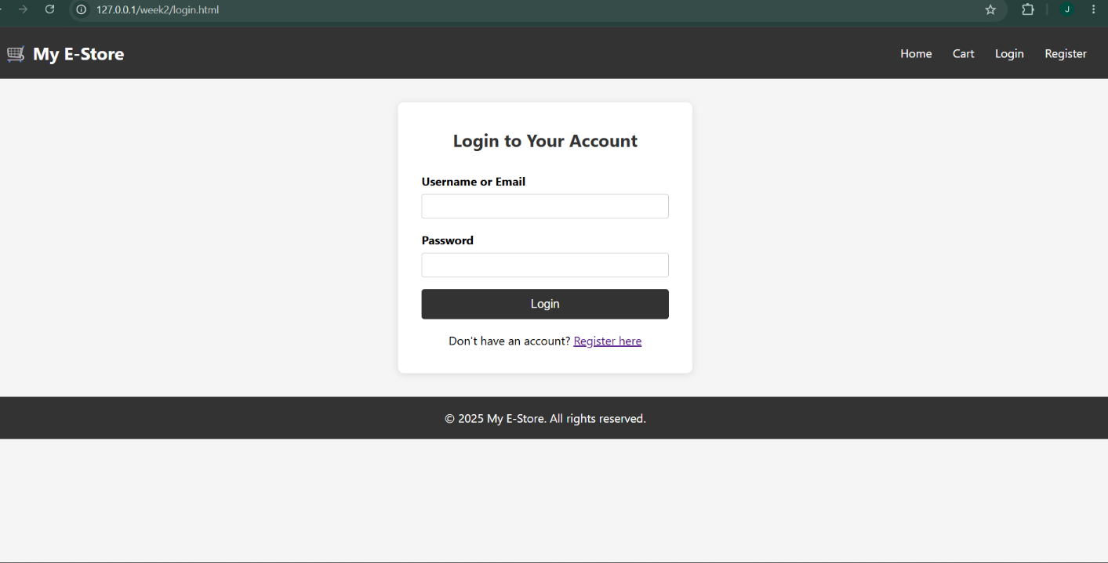
Fig 2.2 displays the login page wireframe with username/email field, password field, login button, and register link.

Fig 2.3: Figma Wireframe - Register Page
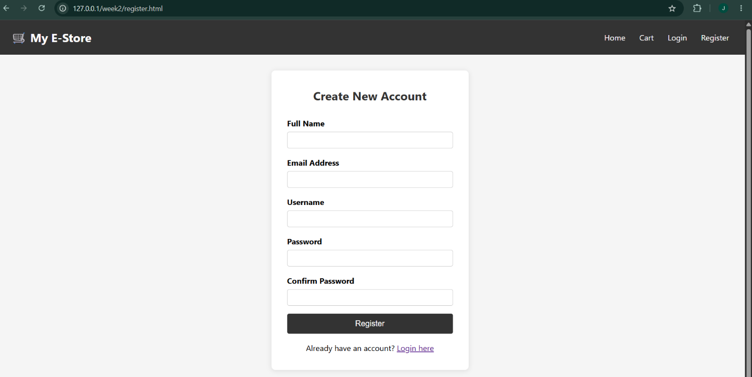

Fig 2.3 shows the registration page wireframe with 5 fields (Full Name, Email, Username, Password, Confirm Password) and register button.

Fig 2.4: Figma Wireframe - Cart Page


Fig 2.4 illustrates the shopping cart wireframe with product table (Product, Price, Quantity, Total, Action), total amount, and checkout button.

Fig 2.5: Working Homepage (HTML/CSS)



4. WEEK 3: JAVASCRIPT AND PHP FOUNDATIONS
Date: June 2, 2026
Theme: Frontend Interaction and Backend Foundations
4.1 Objectives
- Implement JavaScript form validation
- Create password strength checker
- Practice DOM manipulation
- Test PHP syntax
- Practice basic database connection
4.2 Tasks Completed
Task
JavaScript form validation
Email validation (regex)
Password strength checker
DOM manipulation (live preview)
Dynamic menu
PHP syntax practice
Database connection test

Fig 3.1: JavaScript Form Validation

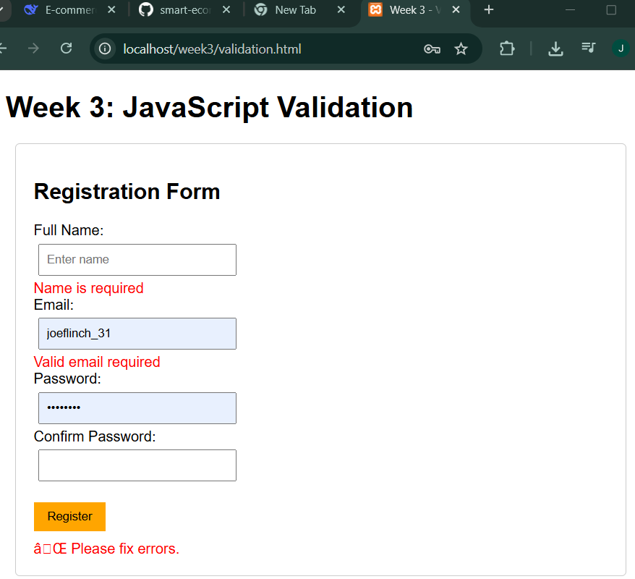
Fig 3.1 shows the JavaScript form validation in action. The registration form includes real-time validation for full name (cannot be empty), email (valid format), password (minimum 6 characters), and confirm password (must match).

Fig 3.2: Password Strength Checker


Fig 3.2 demonstrates the password strength checker. As the user types, the strength meter updates in real-time: Weak (red, 33%), Medium (orange, 66%), Strong (green, 100%).

Fig 3.3: Email Validation
Fig 3.3 shows email validation with a green checkmark appearing when a valid email format is entered (e.g., user@example.com).

Fig 3.4: Live Text Preview (DOM Manipulation)
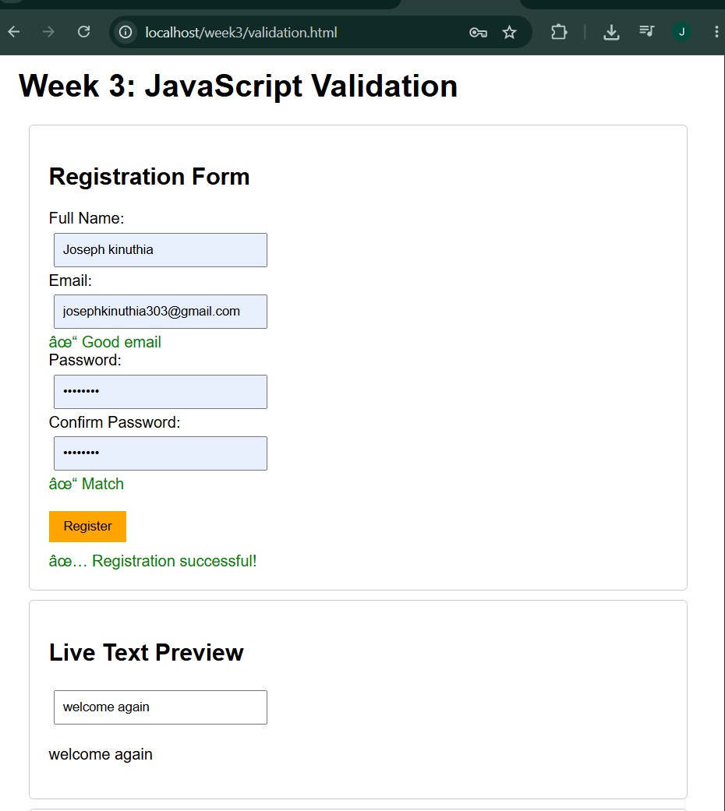

Fig 3.4 illustrates DOM manipulation through live text preview. As the user types in the input field, JavaScript captures the input event and dynamically updates the preview div without refreshing the page.

Fig 3.5: Dynamic Menu - Products Display
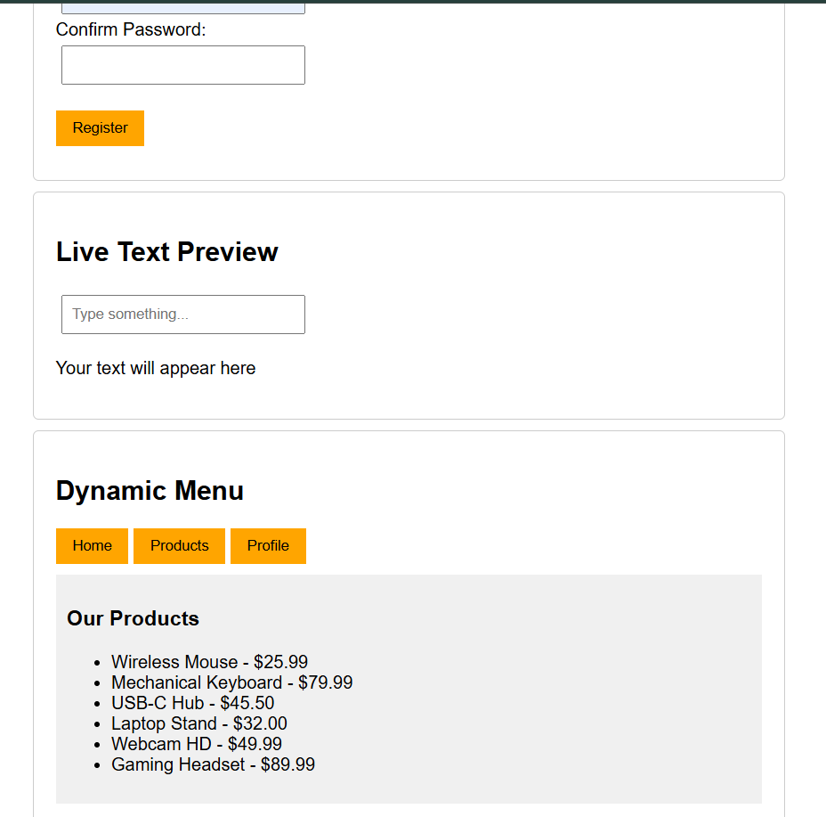

Fig 3.5 shows the dynamic menu where clicking the Products button displays all 6 products without page reload, demonstrating DOM manipulation.

Fig 3.6: PHP Syntax Practice Page

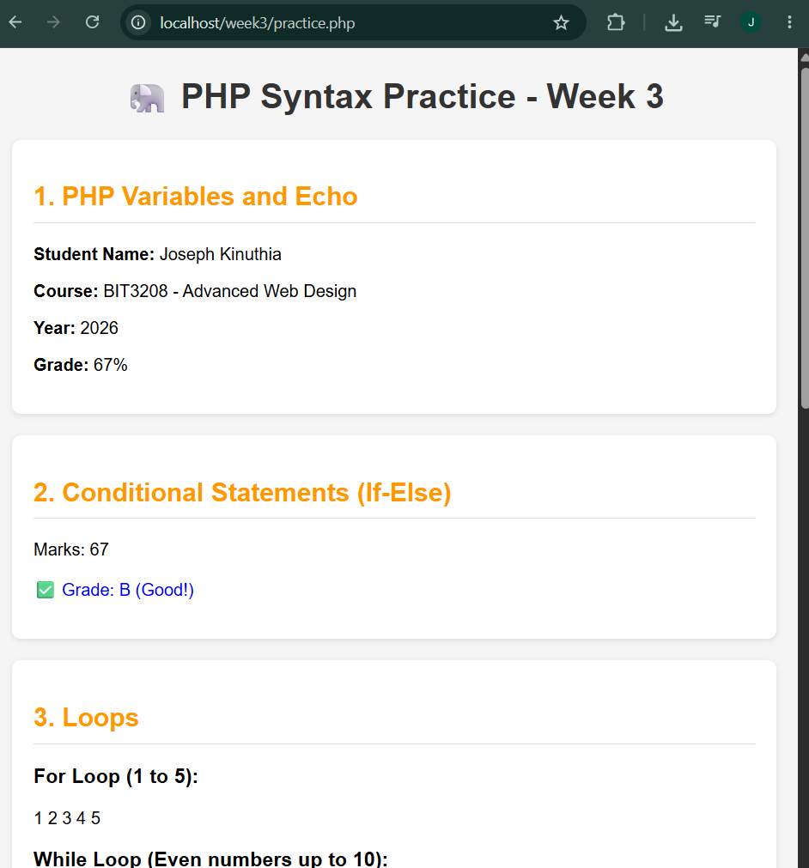

Fig 3.6 displays the PHP syntax practice page demonstrating variables, echo statements, conditional statements (if-else), loops (for, while, foreach), arrays (indexed and associative), and functions.

Fig 3.7: Database Connection Test
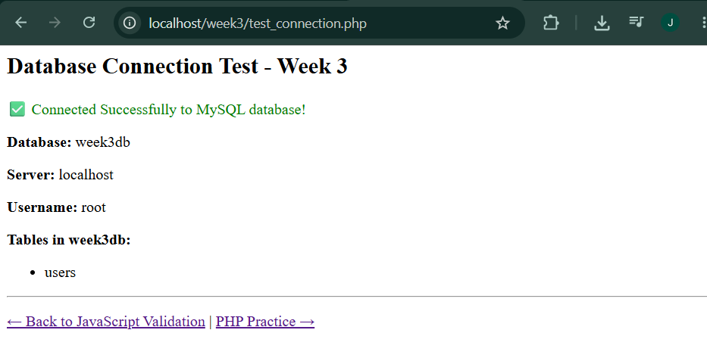

Fig 3.7 shows the successful database connection test with "Connected Successfully" message, confirming PHP-MySQL integration.

4.5 Challenges and Solutions
Challenge | Solution
Password strength meter not updating | Added on input event listener to detect typing
PHP practice page 404 error | Moved file to correct week3 folder in htdocs
Email regex not working | Used proper regex pattern

5. WEEK 4: SERVER-SIDE COMPONENTS
Date: June 3, 2026
Theme: Backend Development Foundations
5.1 Objectives
- Understand server-side programming
- Process forms using PHP
- Create authentication system
- Implement session management
- Structure projects professionally
5.2 Tasks Completed
PHP processing page (process.php)
HTML forms & PHP integration
Registration form with password hashing
Login form with session management
Contact form with validation
Professional folder structure
Modern backend alternatives research
5.3 Evidence
Fig 4.1: Server-Side Processing Page

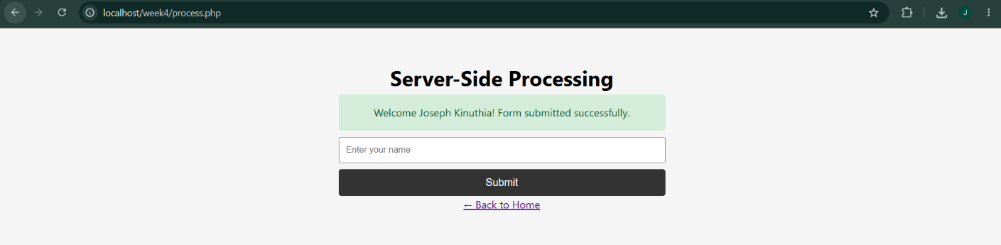

Fig 4.1 shows the server-side processing page demonstrating the request-response cycle. When a user submits their name, PHP processes it and returns a dynamic welcome message.

Fig 4.2: Login Form
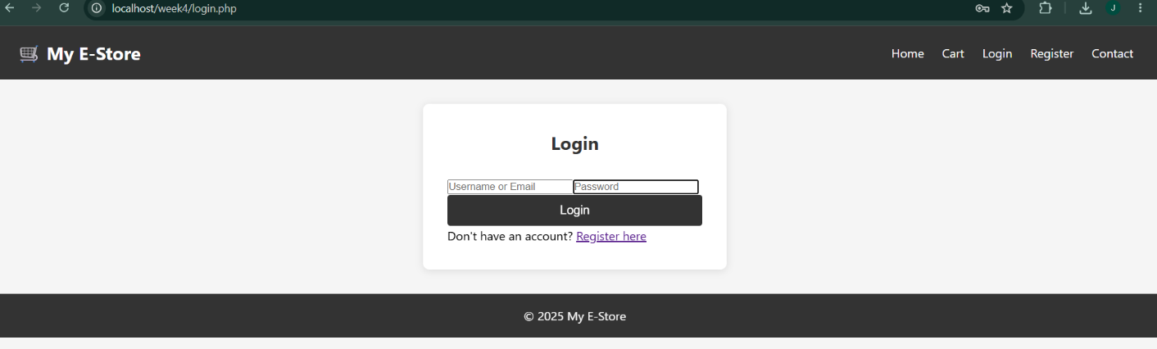

Fig 4.2 displays the login form with username/email field, password field, and login button. The form submits to PHP for authentication.

Fig 4.3: Registration Form with Password Hashing


Fig 4.3 shows the registration form. When submitted, passwords are hashed using password_hash() before being stored in the database.

Fig 4.4: Contact Form with Validation
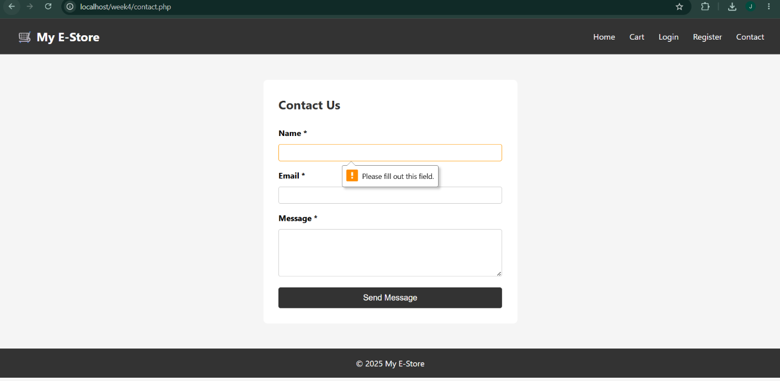

Caption: Fig 4.4 demonstrates the contact form with server-side validation. Empty submissions show error messages, and email format is validated using PHP's filter_var().

Fig 4.5: Dashboard (Protected Page)
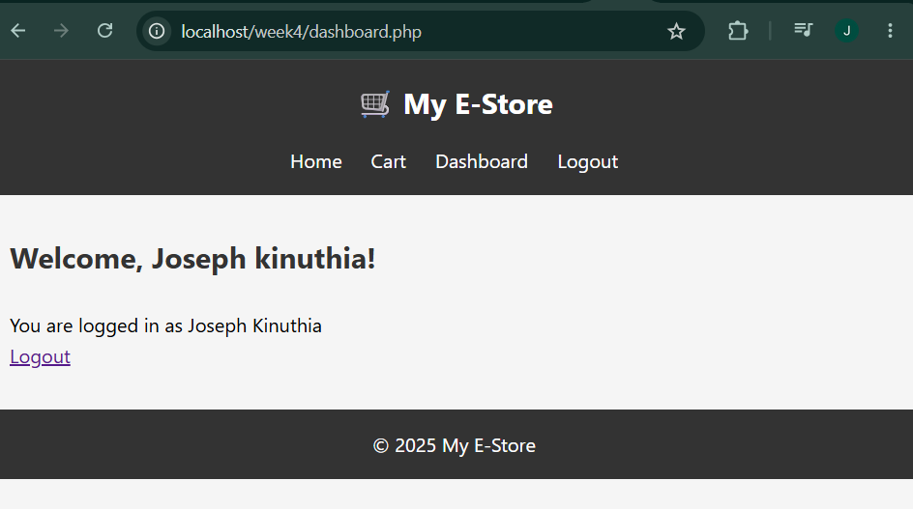

Fig 4.5 shows the user dashboard that is only accessible after successful login, demonstrating session-based protection.

Fig 4.6: Professional Folder Structure

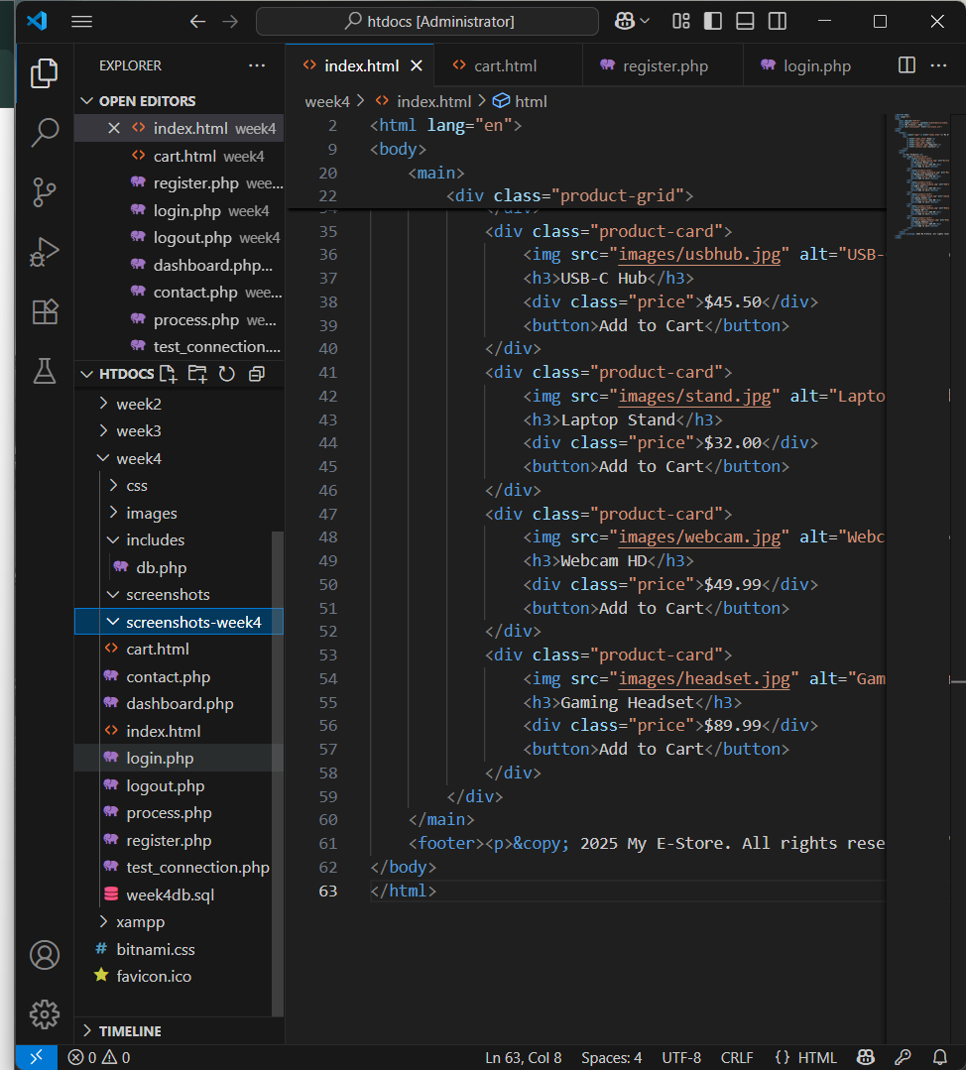

Caption: Fig 4.6 presents the professional folder structure (css/, includes/, images/, database/) following industry best practices.

5.4 Authentication Flow
text
User → Register → Password Hash → Save to Database
↓
User → Login → Verify Password → Create Session → Dashboard
↓
User → Logout → Destroy Session → Login Page
5.5 Security Features Implemented
Feature | Implementation | Code Example
Password hashing | password_hash() | password_hash($password, PASSWORD_DEFAULT)
Password verification | password_verify() | password_verify($password, $hashed_password)
Session management | session_start() | session_start(); $_SESSION['user_id'] = $id;
SQL injection prevention | mysqli_real_escape_string() | mysqli_real_escape_string($conn, $_POST['name'])
XSS prevention | htmlspecialchars() | htmlspecialchars($user_input)
5.6 Modern Backend Alternatives
PHP Concept | Modern Alternative | Use Case
PHP Backend | Node.js, Python Django | Real-time applications
XAMPP | Express.js, Docker | Containerized development
MySQL | MongoDB, PostgreSQL | NoSQL or advanced relational
PHP Sessions | JWT Authentication | Stateless APIs
5.7 Challenges and Solutions
Challenge | Solution
Session not persisting across pages | Added session_start() at the beginning of every page
Password verification failing | Ensured password_verify() uses the same hashed password from database
Contact form validation not working | Used filter_var($email, FILTER_VALIDATE_EMAIL) for email validation
5.8 Time Spent
Activity | Hours
PHP processing pages | 1.0
Forms and integration | 1.5
Authentication system | 1.5
Folder organization | 0.5
Testing and debugging | 1.0
Documentation | 1.0
TOTAL | 6.5 hours

6. WEEK 5: DATABASE AND CRUD OPERATIONS
Date: June 3, 2026
Theme: Database-Driven Web Applications
6.1 Objectives
- Create database and tables
- Perform CRUD operations
- Connect PHP to database
- Fetch and display database records
- Build shopping cart and checkout

6.2 Tasks Completed
Task
Database creation (week5db)
Tables creation (products, users, orders, order_items)
CRUD operations (Create, Read, Update, Delete)
Admin panel for product management
Shopping cart functionality
Checkout and order confirmation
Stock management
6.3 Evidence

Fig 5.1: Database Tables in phpMyAdmin
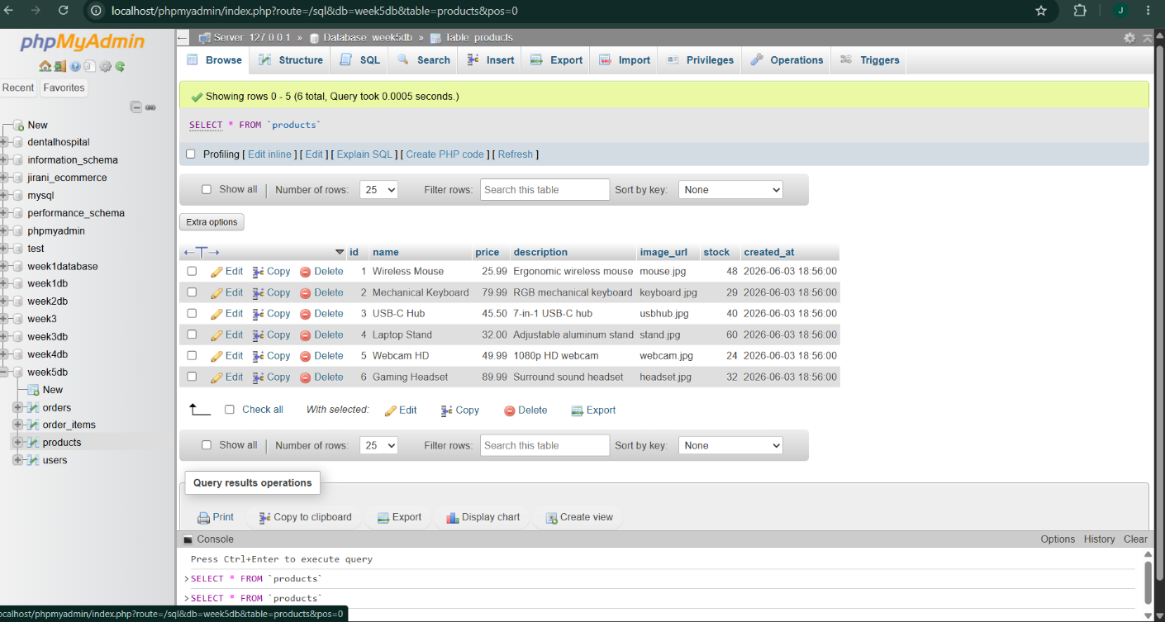 Fig 5.1 shows the complete database structure in phpMyAdmin with four tables: products, users, orders, and order_items.

Fig 5.2: Products Table Data

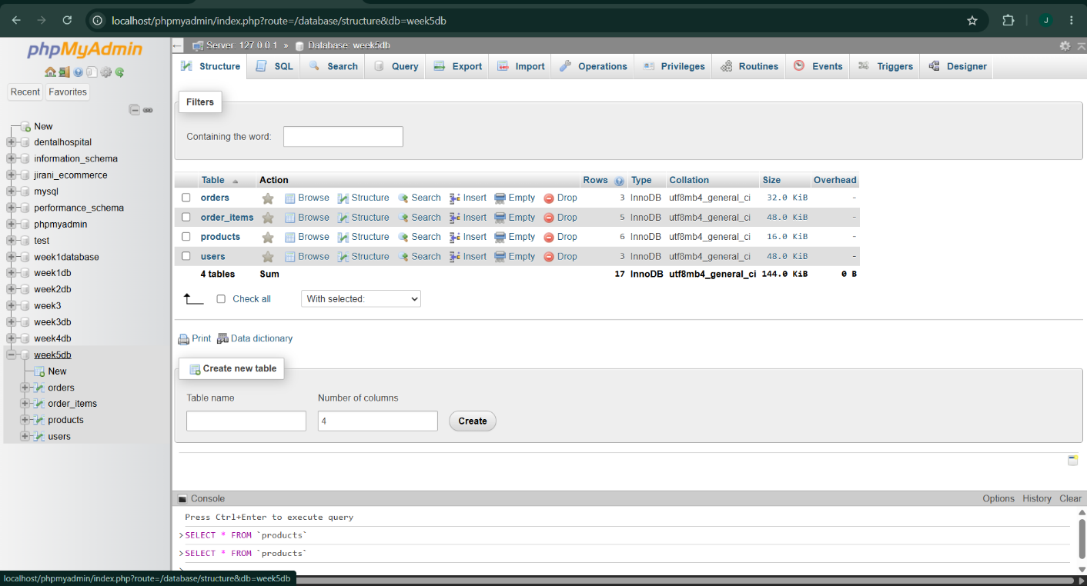

Fig 5.2 displays the products table with 6 sample products including Wireless Mouse, Mechanical Keyboard, USB-C Hub, Laptop Stand, Webcam HD, and Gaming Headset.

Fig 5.3: Admin Panel - Add Product Form
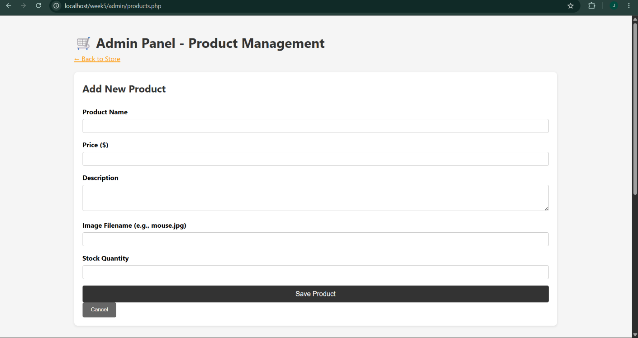

Fig 5.3 shows the admin panel Add Product form where administrators can create new products with name, price, description, image URL, and stock quantity.

Fig 5.4: Admin Panel - Products List with CRUD Operations
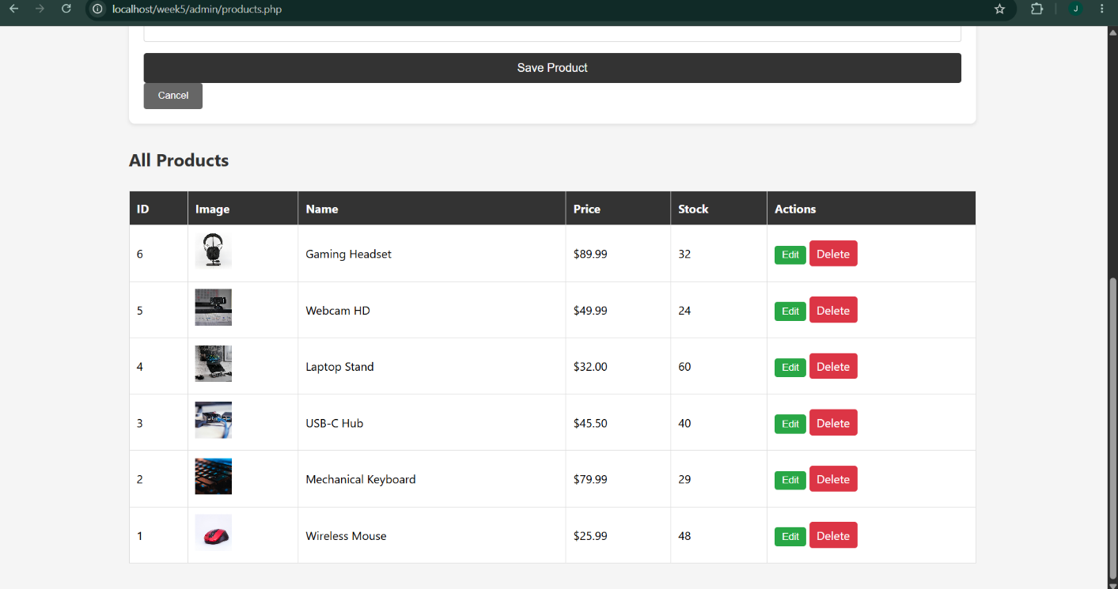

Fig 5.4 displays the products list in the admin panel. Each product has Edit and Delete buttons, demonstrating full CRUD functionality.

Fig 5.6: Shopping Cart

Caption: Fig 5.6 shows the shopping cart with items, quantity selectors, remove button, subtotal calculation, and total amount.

Fig 5.7: Order Confirmation
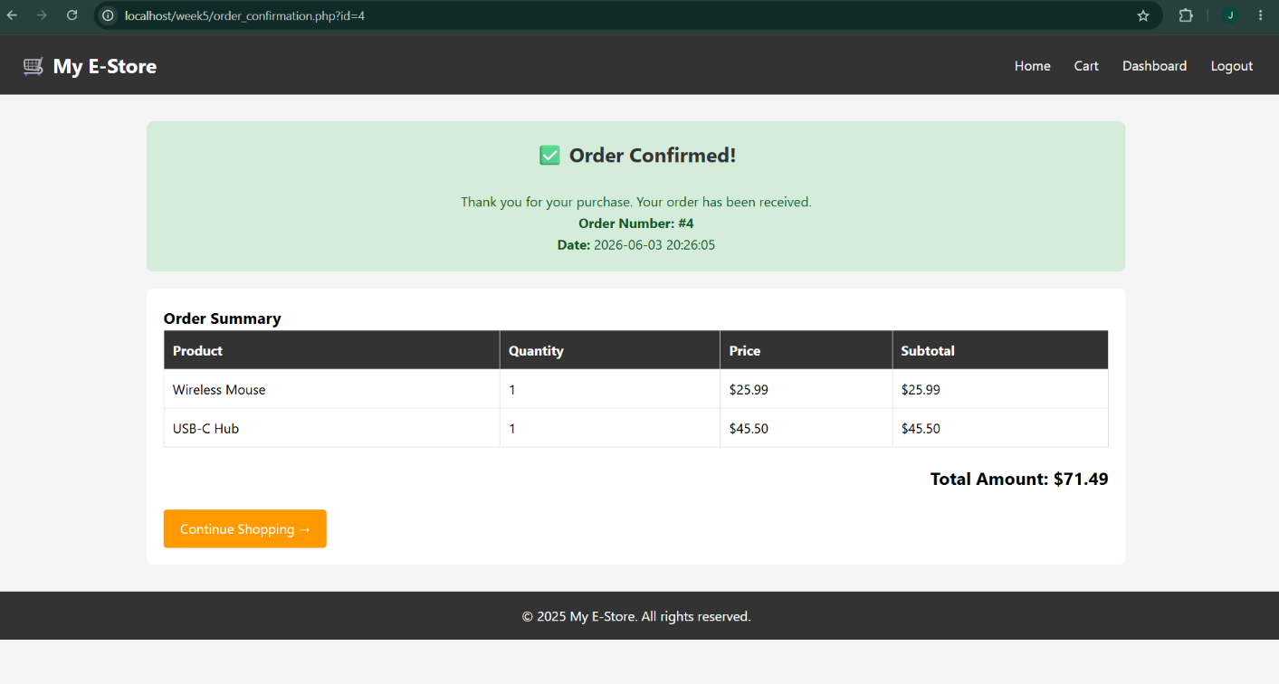
Caption: Fig 5.7 shows the order confirmation page displayed after successful checkout, showing order number, order summary, and total amount.

Fig 5.8: Orders Table in Database
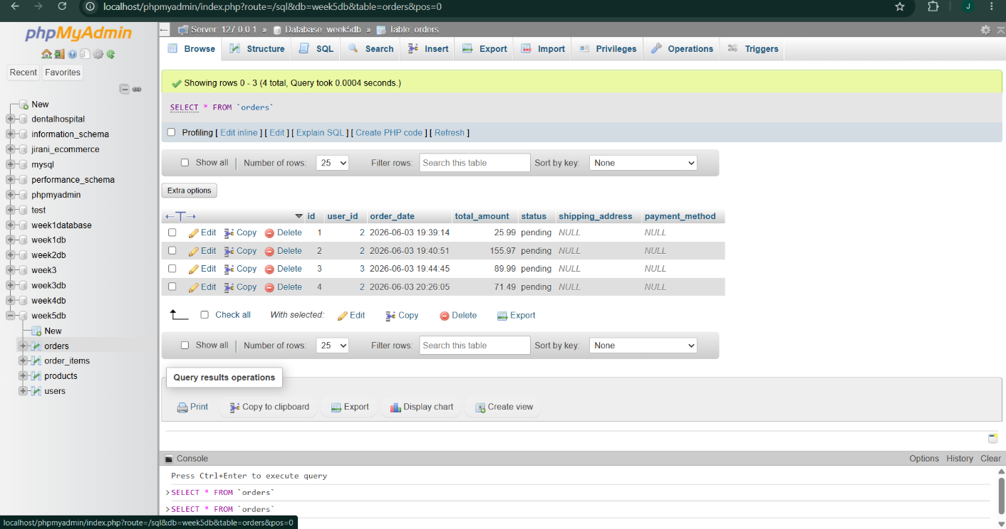

Caption: Fig 5.8 shows the orders table in phpMyAdmin with the placed order including user_id, total_amount, status, and order_date.

Fig 5.9: Order Items Table
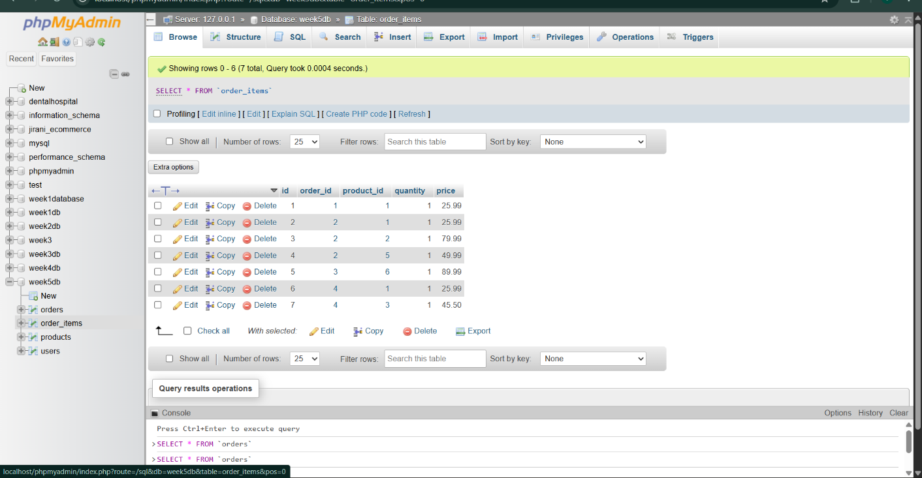

Caption: Fig 5.9 displays the order_items table showing the specific products in the order with quantities and prices.

Fig 5.10: Week 5 Folder Structure
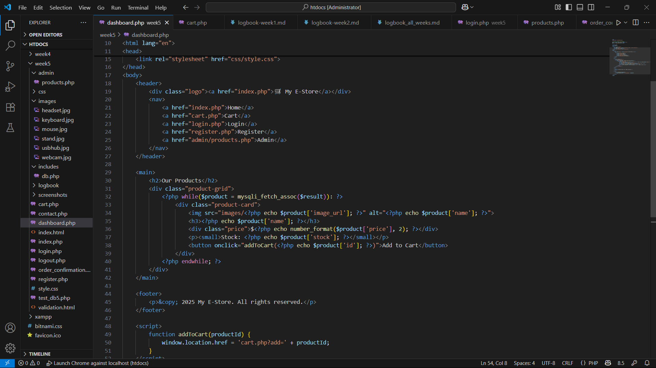

Caption: Fig 5.10 presents the complete Week 5 folder structure including admin/, css/, images/, includes/, and all PHP files.

6.6 CRUD Operations Implemented
Operation | SQL | Implementation
Create | INSERT INTO products | Add Product form in admin panel
Read | SELECT * FROM products | Display on homepage and admin panel
Update | UPDATE products SET... | Edit Product form
Delete | DELETE FROM products | Delete button with confirmation
6.7 Shopping Cart Flow
text
Homepage → Add to Cart → Cart Page → Update Quantity → Checkout
↓ ↓
Session Storage Login Required
↓ ↓
Stock Validation Place Order
↓ ↓
Order Saved to Database ← Order Confirmation
6.8 Challenges and Solutions
Challenge | Solution
Foreign key constraint error when truncating products | Deleted order_items and orders before truncating products
Cart not persisting across pages | Used $_SESSION['cart'] array to store cart data
Stock not updating after order | Added UPDATE query to decrease stock after order placement
Images not displaying on homepage | Ensured image_url matches actual filenames in images folder
7.2 Features Implemented
Category | Features
User System | Registration, Login, Logout, Session Management, Password Hashing, Role-based access
Product Catalog | Dynamic display from database, Product images, Stock tracking, 6 sample products
Shopping Cart | Add items, Update quantities, Remove items, Cart counter, Session storage
Checkout | Stock validation, Order placement, Order confirmation, Database persistence
Admin Panel | Add products, Edit products, Delete products, View all products, Stock management
Interactive | Real-time form validation, Password strength meter, Live text preview, Toast notifications, Confirmation dialogs
7.3 Files Created
Week | Files
Week 1 | index.php, test_db.php
Week 2 | index.html, login.html, register.html, cart.html, css/style.css
Week 3 | validation.html, practice.php, test_connection.php, register.php, login.php, dashboard.php, logout.php
Week 4 | process.php, contact.php, register.php, login.php, dashboard.php, logout.php, includes/db.php
Week 5 | index.php, cart.php, register.php, login.php, dashboard.php, logout.php, order_confirmation.php, admin/products.php, includes/db.php
7.4 How to Access the System
Page | URL
Homepage | http://localhost/week5/index.php
Shopping Cart | http://localhost/week5/cart.php
User Login | http://localhost/week5/login.php
User Registration | http://localhost/week5/register.php
User Dashboard | http://localhost/week5/dashboard.php
Admin Panel | http://localhost/week5/admin/products.php
7.5 Test Accounts
Role | Username | Password | How to Access
Customer | Register at /register.php | User defined | Create new account
Admin | admin | admin123 | Set during database setup

8. CONCLUSION
8.1 Summary of Achievements
This capstone project successfully demonstrates the development of a fully functional e-commerce web application using industry-standard technologies.
Key Accomplishments:
- Complete User Authentication System - Implemented registration, login, session management, and password hashing for security.
- Dynamic Product Catalog - Products are loaded from MySQL database with images, prices, and stock information.
- Shopping Cart - Full cart functionality including add, remove, update quantities, and persistent storage using PHP sessions.
- Order Processing - Checkout system with stock validation, order placement, and order confirmation page.
- Admin Panel - Complete CRUD operations for product management (Create, Read, Update, Delete).
- Responsive Design - Works on desktop, tablet, and mobile devices using CSS Grid and Flexbox.
- Security - Implemented password hashing, SQL injection prevention, and XSS protection.

8.4 Final Remarks
This project has provided hands-on experience in full-stack web development, covering everything from environment setup to database
integration. The skills acquired throughout this 5-week journey are directly applicable to real-world web development scenarios.
The Smart E-Commerce Web Application is portfolio-ready and demonstrates the ability to build professional, secure, and functional web applications.

9. APPENDICES
9.1 Appendix A: All Screenshots Summary
Week | Figure | Description
Week 1 | Fig 1.1 - 1.4 | XAMPP, Hello World, Database connection, phpMyAdmin
Week 2 | Fig 2.1 - 2.9 | Figma wireframes (4), Working pages (4), Folder structure
Week 3 | Fig 3.1 - 3.7 | Form validation, Password strength, Email validation, Live preview, Dynamic menu, PHP practice, Database test
Week 4 | Fig 4.1 - 4.6 | Processing page, Login form, Registration, Contact form, Dashboard, Folder structure
Week 5 | Fig 5.1 - 5.10 | Database tables, Products table, Admin panel (2), Homepage, Cart, Order confirmation, Orders table, Order items, Folder structure
9.2 Appendix B: Database Exports
All database exports are available in the GitHub repository:
- week1db.sql
- week2db.sql
- week3db.sql
- week4db.sql
- week5db.sql
9.3 Appendix C: GitHub Repository
Repository URL: https://github.com/joeflinch31/smart-ecommerce-capstone
Repository Structure:
text
smart-ecommerce-capstone/
├── week1/
├── week2/
├── week3/
├── week4/
├── week5/
├── screenshots/
├── database_exports/
├── Combined_Report.docx
└── README.md

